

Warm up Activity: Order your dinner from the menu and practice making orders with your partner.
Menu
Salads
Greek Salad Cesar Salad Chicken Salad

Appetizer/ Starter
Smoked Salmon Tuna Tartlets Shrimp Cocktail

Soups
Chowder French Onion Lobster Bisque
Pumpkin Gazpacho

Entrée
Pork Sausage Sirloin Steak Lobster Thermidor
Rib Eye Codfish in Mushroom Sauce Chicken Kebab

Dessert
Crème Caramel Tiramisu Chocolate Soufflé
Banana Split Sundae Strawberry Crepe Chestnut Mousse

Practice with your partner.
A: Are you ready to order, madam/sir?
B: Yes, I’d like to start with , and a(n) for appetizer/soup.
A: Have you decided upon an entrée?
B: Yes, I‘d like the .
A: Anything for dessert?
B: Yes, please. I’ll try .
A: Very well, madam/sir. Let me repeat your order, , , , and .
B: That’s right.
A: Your order will be ready soon. Please feel free to let me know if you need anything else.

Conversation

(A guest orders for dinner.)

Waitress: Good evening, sir. Are you ready to order?
Guest: Yes, I’d like Shark’s Fin Soup.
Waitress: Would you like the soup right away or after the other dishes?
Guest: I’ll start with the soup, please.
Waitress: Alright.
Guest: Excuse me, what is “Braised Duck with Eight Jewels”?
Waitress: It is braised duck with eight different condiments.
Guest: It sounds good. I’ll take it. We are interested in a pork dish, too. What do you recommend?
Waitress: Most guests like the Sweet and Sour Pork.
Guest: Hmm… well, I think we’ll try the Braised Pork Belly, thanks. Does that come with Chinese parsley on top?
Waitress: It sure does. Would you care for a side dish?
Guest: Where are the side dishes listed?
Waitress: On the next page, sir.
Guest: We’ll take the Mapo Tofu and Sauteed Cabbage. By the way, we also want to order either rice or noodles along with dish we’ve ordered. What do you recommend?
Waitress: May I suggest the Fried Rice? It is a good dish which goes with seasonal vegetables and fresh shrimp.
Guest: Good. I’ll order 5 portions of the Fried Rice.
Waitress: Would you care for dessert?
Guest: Which one is the most popular in the restaurant?
Waitress: Our Almond Jelly is quite popular with our guests and it has a unique fruity flavor.
Guest: Alright, that sounds wonderful.
Waitress: Is that all for now, sir?
Guest: Yes. Thank you.
Waitress: Your order will be ready soon. If you have any further requests, I’ll be at your service.

Vocabulary

- order
n. 點菜
We would like to order now.

- dish
v. 菜餚 (無複數，dishes是指碟、盤，例如wash the dishes洗碗盤)
The Braised Pork Rice is my favorite dish.

- braise
v. 以文火燉煮
The pork has to be braised for at least 8 hours.

- condiment
n. 佐料
The “Buddha Jumps over the wall” is prepared with many condiments in it.

- recommend
v. 建議
I would recommend you do the homework first before watching TV.

- side dish
n. 小菜
We ordered some side dishes so that there would be enough for our group.

- shrimp
n. 蝦子
My mother cooks shrimp dishes twice a week.

- popular
adj. 受歡迎的
Taroko National Park is popular for its spectacular scenery.

- unique
adj. 獨特的
The design of the craft is very unique.

- flavor
n. 味道
I like the flavor of chocolate.

Phrases

- would you like…/ would you care for… 你想要…
Would you like/ Would you care for another dish?

- right away 馬上
Can we have our dishes served right away? We’re in a hurry.

- I’ll take it. 我要點它。
I’ll take it. The Stinky Tofu sounds good.

- be interested in 對…感興趣
Harry and I are interested in football.

- go with 與…搭配
The cheese goes well with the red wine.

- Is that for all now? 目前先這樣嗎?
Alright, that’s one chocolate cake. Is that for all now?

- I’ll be at your service. 我隨時為你服務。
Your order will be ready soon. For any requests, I’ll be at your service.

Dish Name

1. Shark’s Fin Soup 魚翅湯
2. Braised Duck with Eight Jewels 八寶燉鴨
3. Sweet and Sour Pork 糖醋排骨
4. Braised Pork Belly 紅燒控肉
5. Mapo Tofu 麻婆豆腐
6. Sauteed Cabbage 清炒高麗菜
7. Fried Rice 炒飯
8. Almond Jelly 杏仁豆腐

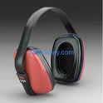 Listening Practice 1: Listen to the conversation again and select the best answer for each question.

- What soup did the guest order?
A. Shark’s Fin Soup B. Corn Soup
C. Sour and Spicy Soup D. Fish ball Soup

2. What is a highly recommended dessert in the restaurant?
A. Strawberry Yogurt.
B. Almond Jelly.
C. Almond Pudding.

Listening practice 2: Review the conversation; then listen to the rephrased questions and choose the best responses.

1. ( ) A. I want to have it before the meal.
B. Afternoon will be better.
C. Yes. It’s at 7:00.
D. I would like to order it right now.
2. ( ) A. Our pasta is quite expensive.
B. I’m sorry. We don’t have the fried rice.
C. No, it is not recommended.
D. The chef’s signature pasta is really famous.
Scripts:
1. When would you like to have your soup, before the meal or after the meal?
2. What dish would you recommend us to order?

Listening practice 3: Listen to the talk and choose the best answers to the following questions.

1. ( ) What is the first thing to offer to the guest when they are seated?
A. The bill.
B. The beverage menu.
C. The invoice.
D. The napkin.
2. ( ) According to the talk, what shouldn’t the waiter do during the order taking?
A. Give the main menu first to the guests.
B. Explain the dishes appropriately.
C. Ask the cook to explain the ingredients of the dish.
D. Seat the guests courteously.

Scripts:
Order taking is a skillful art that reflects the efficiency of both the waiter and the restaurant. An order taken down clearly and precisely ensures that each guest’s needs are well attended to. This is also the time when an order-taker can use his salesmanship by highlighting the recommended items on the menu that yield a high profit margin. After a guest is seated, check with the guest if he or she is comfortable. The first thing to offer him is the beverage menu card, more popularly known as the "Wine List". Besides, the waiter should be on hand to explain dishes. He is therefore required to be familiar with the preparation and final presentation of dishes listed on the Menu card. In addition, his salesmanship will enable him to explain the dishes in an attractive way. An example of this is as follows: "A shrimp cocktail consists of fresh succulent shrimps garnished in tangy cocktail sauce, served on a bed of crisp green lettuce".
Adapted from: http://www.ehow.com/facts_5600324_restaurant-seating-etiquette-hostess.html
The source is from http://www.hbirbals.com/takingorder.htm

Useful Expressions
Common expressions for welcoming and seating the guests

Taking Orders
- Would you like to start with a(n) / some (appetizer/salad/soup/alcoholic beverage/bread…)?
- What will be having for your (entrée/dessert/breakfast…)?
- Anything for dessert/an appetizer/the main dish?
- Can I get you anything from the bar? A cocktail, brandy, whiskey, ouzo…?
- Will that be all for you?

How would you like your steak (cooked/done/prepared)?
- I’d like my steak rare.
medium-rare.
medium.
medium-well
well / well-done

Oral Practice 1: Match the question with the best response.

A. I’d like it well.
B. I want ice cream as my dessert.
C. Yes, I have. I’d like the grilled rib eye.
D. Of course. I’ll give you a few minutes to look over the menu.
E. We have a green salad and Caesar salad.

- Q1. What will you be having for your dessert?
- Q2. How would you like your steak?
- Q3. If I don’t want a set meal, can I order á la carte?
- Q4. Have you decided upon an entrée?
- Q5. What kinds of salad do you have?

B/A/D/C/E

Oral Practice 2: Complete the dialogue using the above information to help you. Then, role-play with your partner.

Waiter: Here is the wine list and entrée menu for you tonight. I’ll come back in few minutes to take your orders.
(Few minutes later)
Waiter:
Guest: Yes, but I have some problems for choosing the soup.
Waiter: As you can see, we have several items for the soup. I would recommend our clam chowder. It is quite popular among visitors to the region.
Guest: Well, As for the appetizer, I want the Caesar salad. For the entrée, I would love to have the grilled rib eye and with some mushrooms on top.
Waiter:
Guest: Medium, please. Are there any French fries as a side?
Waiter: Yes, we have baked, mashed, and French fries for the side dish potatoes choice.
Guest: Then I’ll take the French fries. And for the dessert, I’d like ice cream.
Waiter:
Guest: That’s correct.
Waiter:

Example:
Waiter: Here is the wine list and entrée menu for you tonight. I’ll come back in few minutes to take your orders.
(Few minutes later)
Waiter: Are you ready to order?
Guest: Yes, but I have some problems for choosing the soup.
Waiter: As you can see, we have several items for the soup. I would recommend our clam chowder. It is quite popular among visitors to the region.
Guest: Well, Okay. I’ll take that for my soup. As for the appetizer, I want the Caesar salad. For the entrée, I would love to have the grilled rib eye and with some mushrooms on top.
Waiter: How would you like your steak?
Guest: Medium, please. Are there any French fries as a side?
Waiter: Yes, we have baked, mashed, and French fries for the side dish potatoes choice.
Guest: Then I’ll take the French fries. And for the dessert, I’d like ice cream.
Waiter: Alright. Allow me to repeat your orders. A Caesar salad, a clam chowder, a grilled rib eye with mushrooms and French fries aside, cooked medium, and an ice cream.
Guest: That’s correct.
Waiter: Your orders will be ready soon. If you need any further assistance, please tell me right away.

Reading Practice

Waitress: Good evening, ma’am. Are you ready to order, or do you need a little more time?
Guest: Yes, I’m ready to order.
Waitress: Would you like to start with an hors d’oeuvre?
Guest: Yes. I’d like a shrimp cocktail.
Waitress: How about a soup?
Guest: Minestrone soup, please. I want to have veal steak for the entrée. I’ve heard that’s your signature dish.
Waitress: Yes, that’s right. How would you like your steak ─ Rare, medium, or well done?
Guest: Medium, please.
Waitress: Would you like your steak with a baked potato, or French fries?
Guest: Could I have mashed potatoes instead?
Waitress: I am sorry, Ma’am. We don’t have mashed potatoes. May I suggest a baked potato?
Guest: A baked potato sounds great.
Waitress: Would you like sour cream and chives on that?
Guest: I’ll have sour cream, but hold the chives.
Waitress: And what would you like to drink with your meal?
Guest: I’d like to order wine.
Waitress: The wine list is on the last page of the menu, ma’am.

Vocabulary

- hors d’ oeuvre
n. 開胃菜
I would like to order Parma ham with melon for an hors d’ oeuvre.
- signature dish
n. 招牌菜；特色菜
What is the signature dish in the restaurant?
3. rare
adj. (肉等)三分熟的
I want my steak to be rare.
4. medium (肉等)五分熟的
I want my rib eye to be medium.
- well done
n. (肉等)全熟的
I don’t’ like steak that is well done.
6. instead
adv. 做為替代；反而
I would like to order a chocolate soufflé instead.
7. mashed potato
adj. 馬鈴薯泥
I love mashed potato with salads.
8. chives
n. 細香蔥
Many dishes use chives as decorations.

Dish Name

- Shrimp cocktail 雞尾酒蝦
- Minestrone soup 義式蔬菜湯
- veal steak 小牛排

Practice

order | side dish | popular
right away | go with | medium
braise | signature dish | unique

- Good evening, sir. Are you ready to ?
- What’s the of your chef?
- A: How would you like your steak? B: , please.
- Would you like a to go with the main course?
- Your order will be ready .
- The Stinky tofu has a flavor.
- The pork dish has to be for at least 8 hours.
- The ice cream well apple pie.
- Our cheese cake is very with female guests.

Reading Comprehension check
Activity A: Read the article and answer the following True or False questions.

The proper service of alcoholic beverages is very important because many restaurants are merchandising drinks to satisfy the demand of guests and to increase profits. The waiter’s or waitress’ correct service of alcoholic beverages─wines, beers, and liquors─depends not only on knowing the procedure for serving but also on the knowledge of types of drinks, glassware, beverage temperature, and garnishes. A server should know which beverages complement particular foods on the menu in order to offer suggestions.

Many guests enjoy alcoholic beverages before, with, or after their meals when dining in a restaurant. Wines, beers, and liquors stimulate the appetite of the diner and are palatable companions to all types of foods. They not only make the meal taste better bust also add a festive note to the pleasure of dining in the restaurant.

A waiter or waitress should always suggest drinks with every dinner. Suggest a cocktail, appetizer wine, or beer prior to dinner; wine with dinner; and an after-dinner drink following the meal. Specifically asking whether the guest would like drinks and being especially knowledge about serving drinks add to your merchandising efforts.

Retrieved from: The Waiter & Waitress and Waitstaff Training Hankbook -Page.103
(Lora Arduser & Douglas R. Brown, 2004)

- ( ) According to the article, the guests only enjoy the alcoholic beverages after the meal.
- ( ) Restaurant sells alcoholic beverages to satisfy guests’ demand and make profits.
- ( ) A waiter or waitress should offer beverage suggestions when taking orders.
- ( ) Only wines can go with the food and make the meal taste better.
- ( ) Glassware and temperature are two of the factors that influence the flavors of wines.
Answers: F, T, T, F, T

Activity B: Read the dialogue and fill in the correct answer in the blanks.

Server: Good evening, Sir. Would you like to order now?
Guest: Yes, I think we’re ready. We’d like the lamb and fillet steak with a green salad.
Server: .
Guest: Oh, medium rare, please.
Server: Very good, Sir.
Guest: I’d also like the poached fresh salmon, but can I have fried potatoes instead of baked potatoes?
Server: Certainly, Sir. .
Guest: Well, my friend would like the Chocolate brandy cake, and I’m going for the cherry and almond tart.
Server: Would you like me to bring the wine list?
Guest: Oh, yes, please.
Server: .
Guest: Thank you.
Server: .
Guest: We’ll have one gin, two Scotch on the rocks and a small sherry.
Server: Very good, Sir. .
Guest: Medium dry, please.
Server: Certainly. Thank you, Sir.

- Have you chosen your dessert, Sir?
- Will that be a dry or sweet sherry?
- Here is the wine list, Sir.
- Would you like anything to drink?
- How would you like your steak done, Sir?

Answers: E,A, C,D,B

Activity C: List the order in which restaurant staff do these things.

□a. Ask if guests would like to see the wine list.
□b. Bring the wine list
□c. Serve bread or rolls
□d. Take guests to their table
□e. Receive guests when they arrive
□f. Take guests’ coats to the cloakroom
□g. Take down the orders for the first and second courses
□h. Ask if guest would like an aperitif (a drink before a meal)
□i. Offer water
□j. Take down the wine order
□k. Bring the menu.

Answers: e, f, d, i, h,k,g,a,b,j,c

Grammar Box

When a guest asks questions about the menu, he would say…
I haven’t decided  I can’t make up my mind  I’m wondering… | about | an appetizer  a soup  the main course  a dessert
What would you suggest ______?  What do you recommend _____? | for | an appetizer  a soup  the main course  a dessert

Waiter/ Waitress would answer…
recommend  I would the + {dish name}.  suggest | delicious/ tender/ fresh/excellent.  It’s particularly good.  They’re one of the chef’s specialties.

Phrases describing the composition of dishes
salad.  soup.  It’s a/an appetizer.  main dish.  vegetable dish. | It’s made from | Main ingredients | with | Additional ingredients
 | It’s made from | hard-boiled eggs  onion and potatoes  mince beef  stewed lamb  baked ham | with | French dressing  mayonnaise.  black olives on top.  seasonal fresh fruits.  creamy sauce.  shredded cabbage.

Grammar Practice
Choose the best answer to the question.

1. ( ) Putting about a spoonful of sugar in a glass of water makes it taste .
(A) sweet (B) sweetly (C) sweetness (D) sweeten
2. ( ) My mom made sandwiches.
(A) any (B) some (C) much (D) little
3. ( ) The roast chicken is stuffed bacon, potatoes, and mushrooms.
(A) in (B) from (C) with (D) of
4. ( ) He never eats vegetables.
(A) some (B) enough (C) few (D) any
5. ( ) Besides maple syrup, blueberry syrup also nicely pancakes.
(A) tastes, of (B) goes, with (C) follows, with (D) accompany, of
6. ( ) I would like to try the Johnnie Walker Gold .
(A) on tap (B) on the rocks (C) straight down (D) on the ice.
7. ( ) A: How would you like your rib eye . B: Medium-rare, please.
(A) done (B) cooking (C) prepare (D) made
8. ( ) Would you like to start a salad and soup?
(A) from (B) of (C) with (D) by
9. ( ) The is our most coffee. = This is the coffee that we sell the most.
(A) populist (B) popular (C) welcome (D) welcoming
10. ( ) An Americano is a shot of espresso into a glass of hot water.
(A) poured (B) placed (C) cooked (D) put
11. ( ) How about to the movies tonight?
(A) go (B) to go (C) going (D) see
12. ( ) The chef had his hand by accident when he cooked dinner.
(A) to burn (B) burned (C) burning (D) burn
13. ( ) I haven’t decided the entrée.
(A) as (B) about (C) order (D) of
14. ( ) The dish is made from stewed beef seasonal fresh fruits.
(A) of (B) by (C) with (D) in
15. ( ) Would you like a or an imported beer?
(A) local (B) exported (C) inner (D) national

Fill in the blanks in the story below using the following words and terms.
steak house appetizer (2 times) server liqueur
shrimp cocktail rib steak baked potato budget
after dinner drink business Caesar salad afford
order table earn complimentary

A New Year’s Story

Every year on New Year’s Eve a young couple went out to dinner at their favourite _____
________. They didn’t __________ much money and were on a____________, but they
enjoyed this evening out. One year, after they sat down, they began to discuss what they
were going to _____________. The woman thought about what she wanted before the
meal, and what she wanted after. She decided she wanted to have an ______________of
shrimp, and after the meal she would have a glass of _____________. Her husband
leaned forward and said to her, “I’m sorry, but we don’t have enough money to order both
the_____________ and the ______________.” She decided to have the _____________.
They ate their dinner of__________, ________ _________,and __________, and when
they were through, the server came to their ____________. She said, “One of your friends is
here in the restaurant and wants to offer you a ______________ drink.” The couple looked
around but couldn’t see anybody they knew. But they were happy that they could have the
drink that they couldn’t ___________. When the _____________ came back to their table
with their drinks, they asked her again who had paid for the treat. The server didn’t want to
tell them, but as they were paying, she finally said, “There was a woman from Boston sitting
next to you. She comes in to the restaurant every year on New Year’s while she is here on
_____________. She heard you talking and wanted to give you a gift.”

Retrieved from: http://www.settlement.org/steps/pdfs/FoodWorkbook.pdf

Useful Information

Glassware for beer
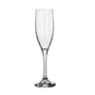  Flute Glass | 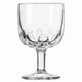  Goblet (or Chalice) | 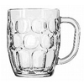  Mug | 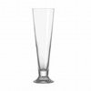Pilsner Glass
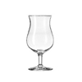Tulip | 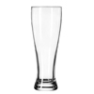  Weizen Glass | 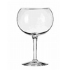  Oversized Wine Glass | 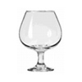Snifter

Retrieved from: http://beeradvocate.com/beer/101/glassware

Introduction of alcoholic beverages:

Port | A strong, usually sweet and often dark red Portuguese wine, usually drunk after a meal.
Sherry | A pale or dark brown strong wine, originally from Spain.
Liqueur | Made from a mixture of spirits, and has a rather sweet taste, usually drunk after a meal.
Brandy | A strong alcoholic drink usually made from wine.
Madeira | A type of strong, usually sweet, wine, produced on the island of Madeira.
Whiskey | A type of strong alcoholic drink made from malted grain such as barley, originally exclusively produced in Scotland.
Beer | A type of bitter alcoholic drink made from grain.
Cocktail | A mixed alcoholic drink.

Retrieved from: English for Hotels and Restaurants (Robert Majure/ Jess Martin, 2010)

French Wine Regions

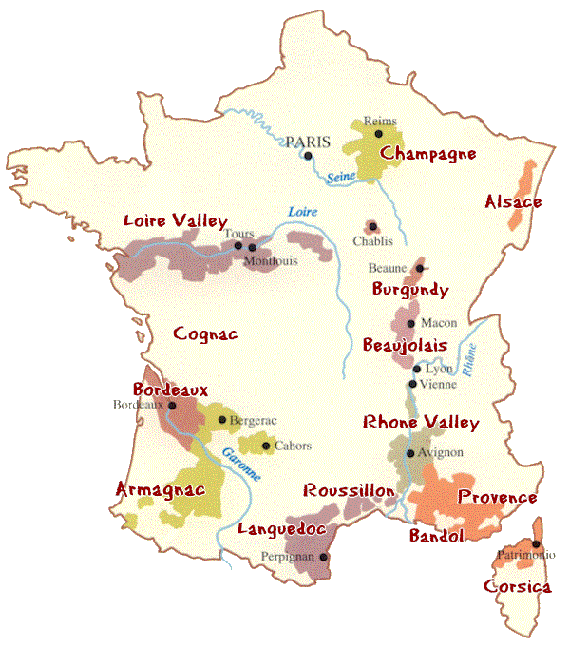
Image retrieved from: http://www.winelist.com/category/wine/

 | Grape Variety
Loire Valley | Chenin Blanc, Sauvignon Blanc, Cabernet Franc
Bordeaux | Cabernet Sauvignon, Cabernet Franc, Merlot, Semillon
South West | Tannat, Manseng, Fer Swervadou, Merille
Burgundy | Pinot Noir, Chardonnay
Champagne | Chardonnay, Pinot Meunier, Pinot Noir
Alsace | Riesling, Pinot Blanc, Sylvaner
Rhône valley | Grenache, Clairette
Roussillon | Merlot, Grenache, Cinsault, Carignan, Cabernet Sauvignon
Loire Valley | Chenin Blanc, Sauvignon

Word Power
Matching!
___ apron  ___ baker’s peel  ___ baking sheet  ___ balloon whisk  ___ baster  ___ blender  ___ chef’s knife  ___ colander/strainer  ___ cooking fork  ___ cutting board  ___ dishwasher  ___ food processor | ___ frying pan (skillet)  ___ hand blender  (immersion blender)  ___ mandoline  ___ measuring cup  ___ mezzaluna  ___ mise en place  ___ mixing bowl  ___ pastry bag, tube  ___ meat pounder  ___ rolling pin  ___ saucepan | ___ scale  ___ scissors/shears  ___ scraper  ___ sieve (chinois)  ___ skimmer  ___ slotted spoon  ___ spatula  ___ steel/sharpener  ___ thermometer  ___ toaster  ___ tongs  ___ wooden spoon

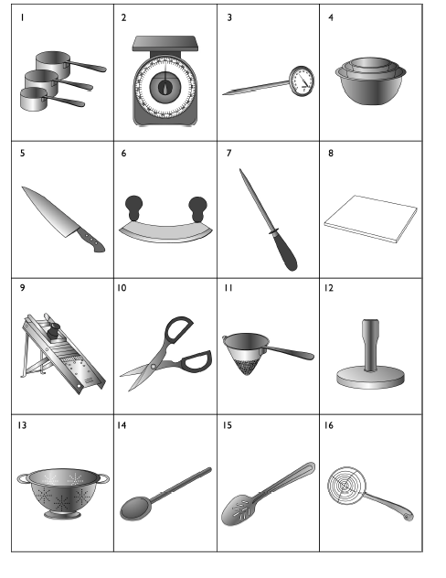
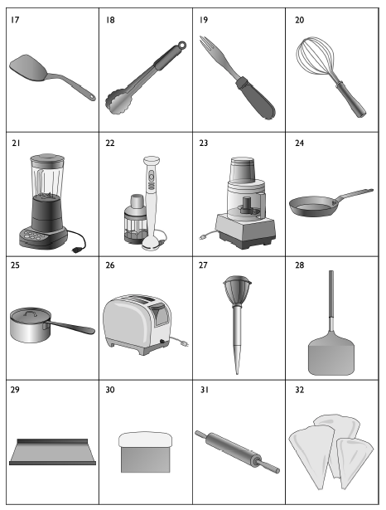
Retrieved from: http://www.settlement.org/steps/pdfs/FoodWorkbook.pdf

Final Lesson Practice

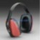 Practice 1 Question-Response: Listen and choose the best responses.

1. Mark your answer. A B C

2. Mark your answer. A B C

3. Mark your answer. A B C

4. Mark your answer. A B C

Scripts:
1. How would you like your steak?
(A) Yes, It will be better.
(B) Medium, please.
(C) It is good.
2. Are you ready to order?
(A) Yes, please.
(B) No, I think it is not good at all.
(C) Could you repeat your last name for me, sir?
3. Anything for dessert?
(A) I would love to have the salad.
(B) I’ll take an apple tart.
(C) Is there anything to choose from the pasta courses?
4. Does the steal come with the mushrooms on top?
(A)The mushroom will be cooked.
(B) Yes, the mushrooms will be on top.
(C) The potatoes will come with the steak.

Practice 2: Short Talk: Listen to the short talk and choose the best answer.

1. What does Mr. Walter order for his dessert?
(A) The fruit yogurt.
(B) The fruit tart.
(C) The fruit pudding.

2. When does Mr. Walter want his drinks to be served?
(A) Before the meal.
(B) During the meal.
(C) After the meal.

Script:
Waiter: Mr. Walter, are you ready to order?
Mr. Walter: Yes. I want the green salad with the Italian dressing for the appetizer.
Waiter: What will you be having for the entrée?
Mr. Walter: I’d love to try the lasagna, please.
Waiter: Anything for beverage and dessert?
Mr. Walter: Fruit pudding and cappuccino.
Waiter: Would you like your cappuccino served before the meal or after the meal?
Mr. Walter: I want it after the meal.
Waiter: Alright. Let me repeat your orders. A green salad with Italian dressing, a lasagna, a fruit pudding and a cappuccino served after the meal.
Mr. Walter: Yes, that’s right.

Practice 3 Language function practice-Food and Beverage Conversation

1. How big are the portions?
Enough.
Each meal comes with either soup or salad.
Generally, our portions are very big.
2. Is this dish very spicy? I can only eat mild food.
Yes, it's very good. Would you like to order it?
It's spicy, but we can make a mild version for you if you like.
Yes, we can make it very spicy.
3. Can I have my steak medium? This is well-done.
I'm sorry, I will tell our cook to prepare a new one for you.
It is medium already. There’s not much I can do for you, I’m afraid.
Please wait five minutes and I’ll be right back with the menu.
4. Three breakfast specials, please.
What kind of eggs do you prefer?
What style of egg preparation would you like?
How would you like your eggs?
5. Is this entree big enough to share?
Yes. It's big enough for two people.
Yes, would you like two?
Would you like an extra plate?
Retrieved from http://www.englishformyjob.com/english-for-restaurant-staff3.html

